What He Said There - Sarah Vowell

There are children playing soccer on a field at Gettysburg where the Union Army lost the first day’s fight. Playing soccer, like a bunch of Belgians - and in the middle of football season no less. Outside of town, there’s a billboard for a shopping mall said to be “The Gettysburg Address For Shopping.” Standing on the train platform where Abraham Lincoln disembarked from Washington on November 18, 1863, there’s a Confederate soldier, a reenactor. “Which direction is south?” I ask him, trying to re-create the presidential moment. When the fake Johnny Reb replies that he doesn’t know, I scold him, “Dude, you’re from there!”. Around the corner, citizens of Gettysburg stand in line at the Majestic Theatre for the 2:10 showing of Meet The Parents. Bennett, the friend I’m with, makes a dumb joke about Lincoln meeting his in-laws, the Todds. “Things did not go well,” he says.

It is November 19, 2000, the 137th anniversary of the cemetery dedication ceremony at which Lincoln delivered a certain speech. “Four score and seven years ago,” Lincoln said, referring to the Declaration of Independence in 1776, “our fathers brought forth on this continent a new nation, conceived in Liberty, and dedicated to the proposition that all men are created equally.” Always start with the good news.

I could say I’ve come to Gettysburg as a rubbernecking tourist, that I’ve shown up to force myself to mull over the consequences of a war I never think about. Because that would make a better story - a gum-chewing, youngish person who says “like” too much, comes face to face with the horrors of war and Learns Something. But, like, this story isn’t like that. Fact is, I think about the Civil War all the time, every day. I can’t even use a cotton ball to remove my eye makeup without spacing out about slavery’s favourite cash crop and that line from Lincoln’s Second Inaugural Address that “it may seem strange that any men should dare to ask a just God’s assistance in wringing their bread from the sweat of other men’s faces.” Well, that, and why does black eyeliner smudge way more than brown?

I guess Gettysburg is a pilgrimage. And, like all pilgrims, I’m a mess. You don’t cross state lines to attend the 137th anniversary of anything unless something’s missing in your life.

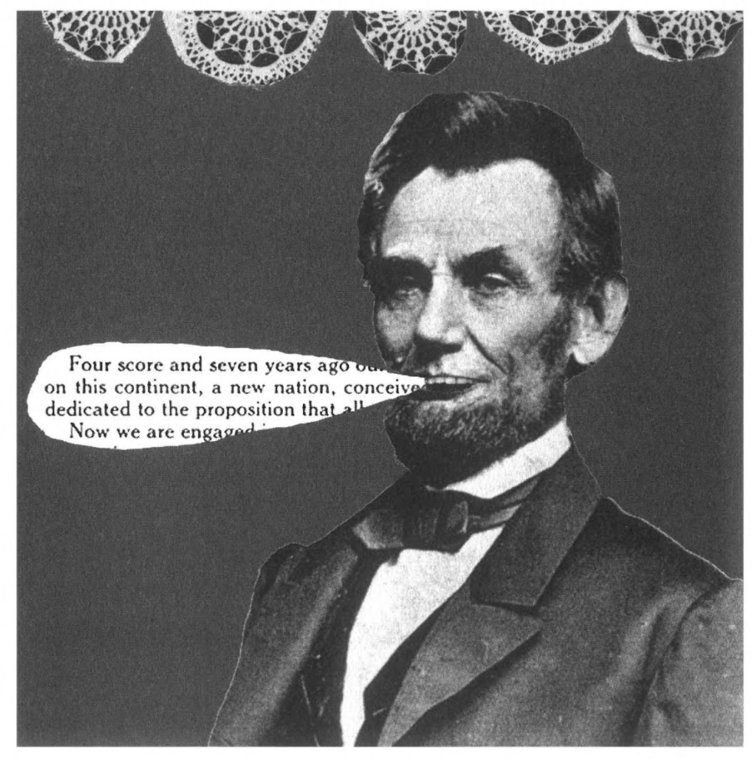

The fighting at Gettysburg took place between July 1 and July 3, 1863. The Union, under the command of General George Meade, won. But not at first, and not with ease. In the biggest, bloodiest battle ever fought on U.S. soil, 51,000 men were killed, wounded, or missing. I am interested enough in that whopping statistic to spend most of the day being driven around the immense battlefield. Interested enough to walk down a spur on Little Round Top to see the monument to the 20th Maine, where a bookish but brave college professor named Joshua Lawrence Chamberlain ran out of ammo and ordered the bayonets that held the Union’s ground. Interested enough to stop at the Copse of Trees - where the Confederate General George Pickett aimed his thousands of soldiers who were mowed down at the climax - and sit on a rock and wonder how many Southern skulls were cracked open on it.

I care enough about the 51,000 to visit the graves, semicircular rows of stones with the otherwise forgotten names of Jeremiah Davis and Jesse Wills and Wesley Raikes laid right next to Hiram Hughes. And the little marble cubes engraved with numbers assigned the unknown. Who was 811? Or 775? The markers for the unknowns are so minimal and so beautiful I catch myself thinking of these men as sculptures. Here, they are called “bodies”. There are slabs chiseled MASSACHUSETTS 159 BODIES and CONNECTICUT 22 BODIES and WISCONSIN 73 BODIES.

So I pay my respects to the bodies, but I’ll admit that I am more concerned with the 272 words President Lincoln said about them. The best the slaughtered can usually hope for is a cameo in some kind of art. Mostly, we living need a Guernica to remind us of Guernica. In the Gettysburg Address, Lincoln said of the men who shed their blood, “The world will a little note, nor long remember, what we say here, but it can never forget what they did here.” Who did he think he was kidding? We only think of them because of him. Robert E. Lee hightailed it out of Gettysburg on the Fourth of July, the same day the Confederates surrendered Vicksburg to U.S. Grant - a big deal at the time because it gave the Feds control of the Mississippi. And yet who these days dwells on Vicksburg, except for the park rangers who work there and a handful of sore losers who whine when they’re asked to take the stars and bars off their godforsaken state flags?

The Gettysburg Address is more than a eulogy. It’s a soybean, a versatile little problem solver that can be processed into seemingly infinite, ingenious products. In this speech, besides cleaning up the founding fathers’ slavery mess by calling for a “new birth of freedom”, Lincoln comforted grieving mothers who would never bounce grandchildren on their knees and ran for reelection at the same time. Lest we forget, he came to Washington from Illinois. Even though we think of him as the American Jesus, he had a little Mayor Daley in him too. Lincoln the politician needed the win at Gettysburg and, on the cusp of an election year, he wanted to remind the people explicitly that they could win the war if they just held on, while implicitly reminding them to use their next presidential ballot to write their commander in chief a thank-you note.

Privately, Lincoln has mixed feelings about Gettysburg because he’s certain the war could have ended right here if only General Meade had not let General Lee get away. According to a letter written right after the battle, Lincoln is “deeply mortified” that “Meade and his noble army had expended all the skill, and toil, and blood, up to the ripe harvest, and then let the crop go to waste”. Because Lincoln is a good man, he does not say this in front of the families who came to the cemetery to hear that their loved ones “shall not have died in vain”. Because he is a good politician, he looks on the bright side. Though I personally suspect that in Lincoln’s first draft, the line about how “it is for us the living, rather, to be dedicated here to the unfinished work which they who have fought here have thus far so nobly advanced” was simply “Goddamn fucking Meade”.
Abraham Lincoln is one of my favourite writers. “The mystic chords of memory.” “Better angels of our nature.” “The father of waters flows unvexed into the sea.” All those brilliant phrases I’d admired for so long, and yet I never truly thought of him as a writer until I visited the David Wills house in Gettysburg town square.

In 1863, Wills was charged by Pennsylvania’s governor to oversee the battlefield’s cleanup and the construction of the cemetery. His house, now a museum, is where Lincoln stayed the night before delivering the address. I walk into the room where Lincoln slept, with its flowery carpet and flowery walls, with its canopy bed and its water pitcher and towels, and for several minutes the only possible thought is that he was here. There’s the window he leaned out of the night of the 18th, teasing the crowd outside that he had nothing to say. And, this being a sweet old-fashioned tourist trap, there’s a gangly Lincoln mannequin in white shirtsleeves, hunched over a small table, his long legs poking out the side. He’s polishing the speech. The myth is that he wrote it on the back of an envelope on the train, but probably he’s been slaving over it for days and days. Still, he doesn’t finish it until he’s in this room, the morning of the 19th, the morning he’s to deliver it.

To say that Abraham Lincoln was a writer is to say that he was a procrastinator. How many deadlines have I nearly blown over the years, slumped like Lincoln, fretting over words that didn’t come out until almost too late? Of course, the stakes are lower when one is under pressure to think up insightful things to say about the new Brad Pitt movie instead of, say, saving the Union. On the other hand, I’ve whipped out Aerosmith record reviews that are longer than the Gettysburg Address, so where’s my mannequin?

Looking at Lincoln rushing to stave off failure, I felt so close to him. Or let’s say I felt closer. My grandest hope for my own hastily written sentences is that they would keep a stranger company on an airplane. Abraham Lincoln could turn a pretty phrase such as “I invoke the considerate judgement of mankind” and put in the proclamation that freed the slaves. Even Mailer wouldn’t claim to top that.

At the Gettysburg National Cemetery, there’s a ceremony every November 19 to celebrate the anniversary of Lincoln’s speech. I sit down on a folding chair among the shivering townspeople. A brass band from Gettysburg High School plays the national anthem. The eminent Yale historian James McPherson delivers a speech he may have written a long time ago to make college students feel bad. Because when he accuses the audience of taking our democracy for granted, there’s a rustling in the crowd. While people who commemorate the anniversary of the Gettysburg Address surely have a lot of problems, taking democracy for granted isn’t one of them. New Jersey’s governor, Christine Todd Whitman, then takes the podium, proclaiming, “Our government doesn’t have all the answers, and it never will.” That is code for “Sorry about that icky photo that shows me laughing as I frisk an innocent black man on a State Police ride-along.”

I sit through all of this, impatient. I didn’t come here for the opening acts. Like a Van Halen concertgoer who doesn’t high-five his friend until he hears the first bar of “Jump”, all Ive been waiting for is for the Lincoln impersonator James Getty to stand up and read the Gettysburg Address already. This is what Garry Wills says happened after Lincoln stopped talking in 1863: “The crowd departed with a new thing in its ideological luggage, that new constitution Lincoln had substituted for the one they brought there with them. They walked off, from those curving graves on the hillside, under a changed sky, into a different America”. This is what happened after the Lincoln impersonator stopped talking in the year 2000: The eight-year-old boy sitting next to me pointed at Getty and asked his mom, “Isn’t that guy too short?”

I glanced at the kid with envy. He’s at that first, great, artsy-craftsy age when Americans learn about Abraham Lincoln. How many of us drew his beard in crayon? We built models of his boyhood cabin with Elmer’s glue and toothpicks. We memorized the Gettysburg Address, reciting its ten sentences in stovepipe hats stapled out of black construction paper. The teachers taught us to like Washington and to respect Jefferson. But Lincoln - him they taught us to love.

